LAB EXPERIMENT RECORD
SET 5: WEBSITE ANALYTICS
Department | AIDS
Course Code / Course Name | DSA0601 / Data Handling and Visualization
Experiment | Data Visualization using R
Name | B. Pallavi
Register Number | 192424243
Date | 01 October 2026
Day | Thrusday

Aim
To analyze website traffic data using a line chart, bar chart, stacked area chart, and interactive dashboard using R and Tableau.
Dataset: Website Analytics
Date | Page Views | Click-through Rate
2023-01-01 | 1500 | 2.3%
2023-01-02 | 1600 | 2.7%
2023-01-03 | 1400 | 2.0%
2023-01-04 | 1650 | 2.4%
2023-01-05 | 1800 | 2.6%
PROGRAM 1: Line Chart of Daily Page Views
Create a line chart to visualize the daily page views. Label the axes and title the chart appropriately.
# Dataset
date <- as.Date(c(
"2023-01-01",
"2023-01-02",
"2023-01-03",
"2023-01-04",
"2023-01-05"
))

page_views <- c(1500, 1600, 1400, 1650, 1800)

# Line Chart
plot(date,
page_views,
type = "o",
xlab = "Date",
ylab = "Page Views",
main = "Daily Page Views",
pch = 19,
col = "blue")

Output 1: Daily Page Views Line Chart
Observation: Page views decrease on January 3 and then increase from January 4 to January 5. The highest page views are recorded on January 5.

PROGRAM 2: Bar Chart of Top N Days by Click-through Rate
Create a bar chart to display the days having the highest click-through rates.
# Dataset
date <- as.Date(c(
"2023-01-01",
"2023-01-02",
"2023-01-03",
"2023-01-04",
"2023-01-05"
))

ctr <- c(2.3, 2.7, 2.0, 2.4, 2.6)

# Select Top 3 Days
data <- data.frame(Date = date, CTR = ctr)

top3 <- data[order(-data$CTR), ][1:3, ]

# Bar Chart
barplot(top3$CTR,
names.arg = format(top3$Date, "%Y-%m-%d"),
xlab = "Date",
ylab = "Click-through Rate (%)",
main = "Top 3 Days by Click-through Rate",
col = "skyblue")
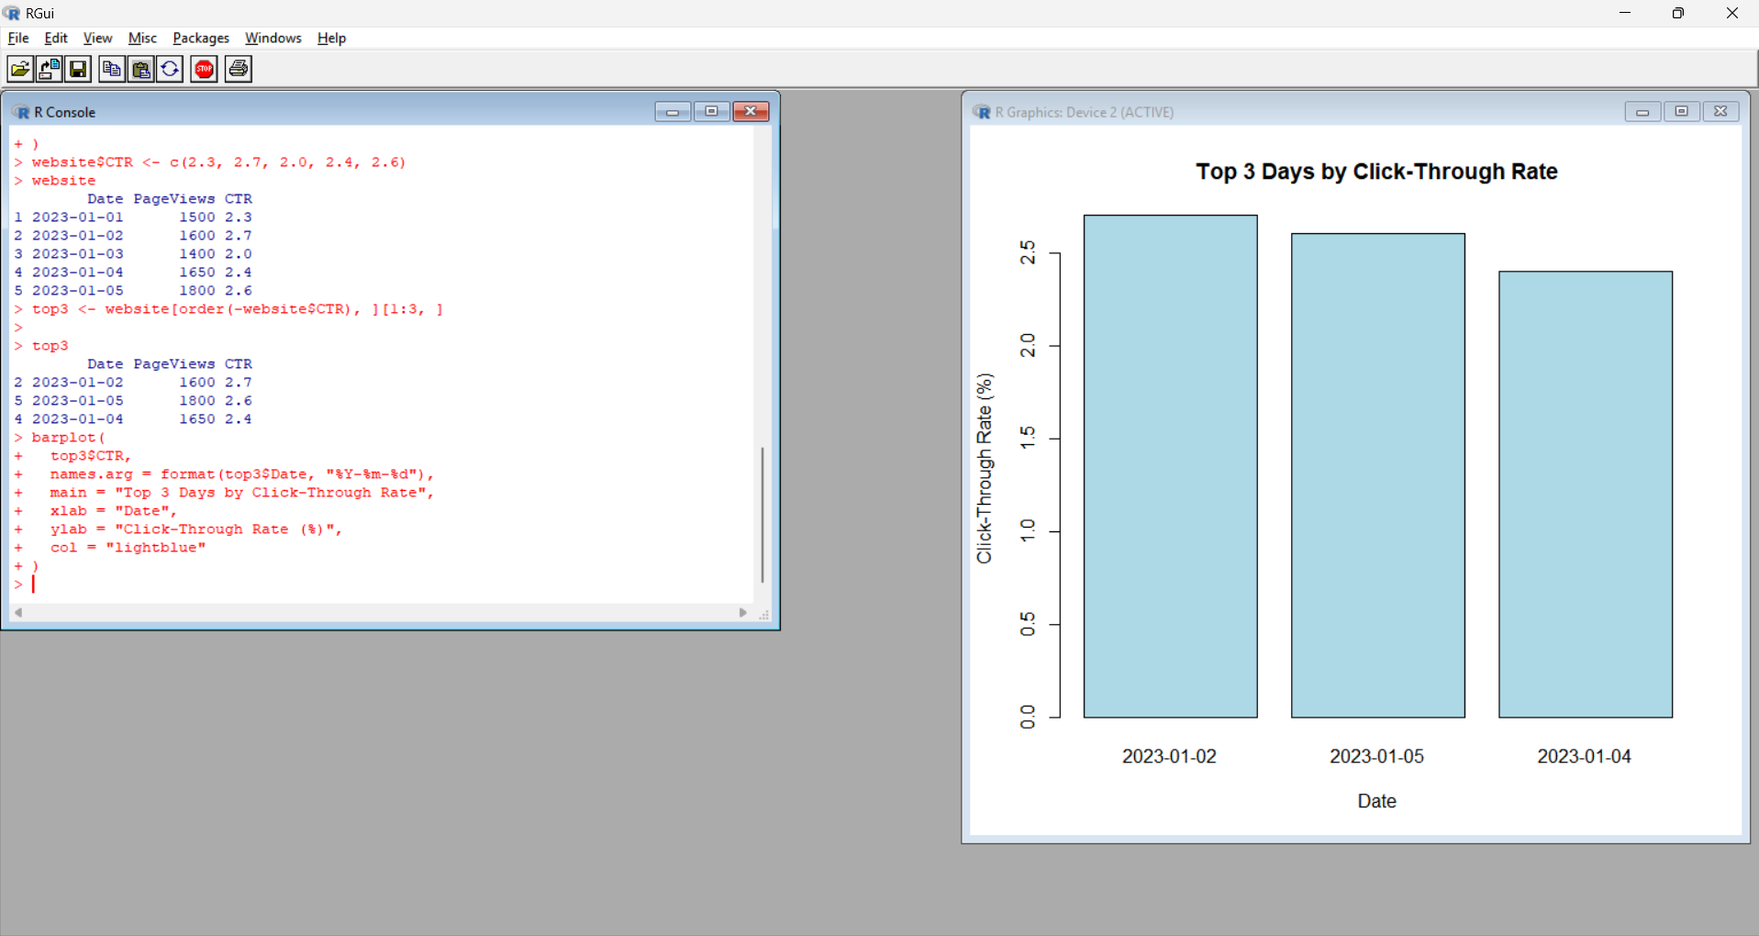
Output 2: Top 3 Days by Click-through Rate Bar Chart
Observation: January 2 has the highest click-through rate of 2.7%, followed by January 5 with 2.6% and January 4 with 2.4%.

PROGRAM 3: Stacked Area Chart of Website Interactions
Develop a stacked area chart to visualize likes, shares, and comments over time.
Note: Likes, shares, and comments are not included in the supplied website dataset. Therefore, the following values are sample interaction data.
Date | Likes | Shares | Comments
2023-01-01 | 100 | 30 | 20
2023-01-02 | 120 | 35 | 25
2023-01-03 | 90 | 25 | 15
2023-01-04 | 130 | 40 | 30
2023-01-05 | 150 | 45 | 35
Step 1 — Install packages
Run these only if they are not already installed:
install.packages("ggplot2")
install.packages("tidyr")
Step 2 — Load packages
library(ggplot2)
library(tidyr)
Step 3 — Enter the data
# Dataset
interaction <- data.frame(
Date = as.Date(c(
"2023-01-01",
"2023-01-02",
"2023-01-03",
"2023-01-04",
"2023-01-05"
)),
Likes = c(100, 120, 90, 130, 150),
Shares = c(30, 35, 25, 40, 45),
Comments = c(20, 25, 15, 30, 35)
)
Step 4 — Convert data to long format
interaction_long <- pivot_longer(
interaction,
cols = c(Likes, Shares, Comments),
names_to = "Interaction",
values_to = "Count"
)
Step 5 — Create stacked area chart
ggplot(interaction_long,
aes(x = Date,
y = Count,
fill = Interaction)) +
geom_area() +
labs(
title = "Website User Interactions",
x = "Date",
y = "Number of Interactions"
)
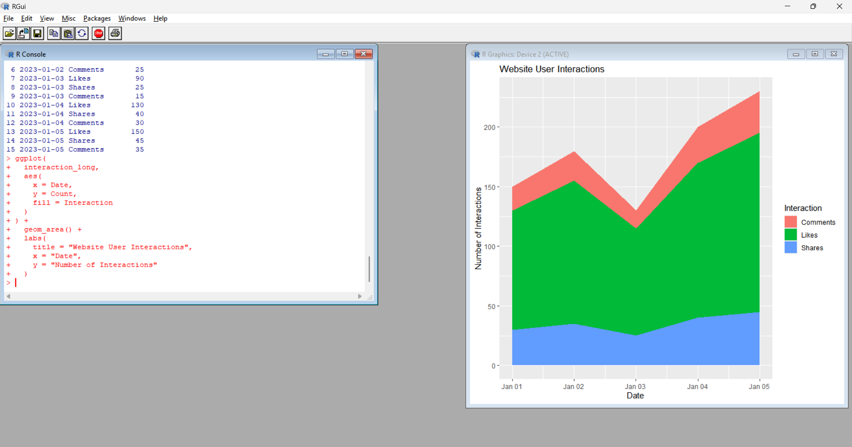
Output 3: Website User Interactions Stacked Area Chart
Observation: The stacked area chart shows the changes in likes, shares, and comments over the given dates. Overall interaction levels are higher on January 5.

PROGRAM 4: Interactive Website Analytics Dashboard
Build an interactive dashboard combining the daily page views line chart and click-through rate bar chart using Tableau.
Excel Dataset for Tableau
Create an Excel file named:
Website_Traffic.xlsx
Enter:
Date | Page Views | Click-through Rate
2023-01-01 | 1500 | 2.3
2023-01-02 | 1600 | 2.7
2023-01-03 | 1400 | 2.0
2023-01-04 | 1650 | 2.4
2023-01-05 | 1800 | 2.6
Important: In Excel, enter the CTR values as 2.3, 2.7, 2.0, etc., without the % symbol.
Tableau Steps
- Open Tableau.
- Select Microsoft Excel.
- Open Website_Traffic.xlsx.
- Click Sheet 1.
- Drag Date → Columns.
- Drag Page Views → Rows.
- Select Line from the Marks card.
- Rename the sheet Daily Page Views.
- Create a new worksheet.
- Drag Date → Columns.
- Drag Click-through Rate → Rows.
- Select Bar.
- Rename the sheet Click-through Rate.
- Create a New Dashboard.
- Drag Daily Page Views into the dashboard.
- Drag Click-through Rate into the dashboard.
- Set the title as Website Traffic Analytics Dashboard.
- Use Date as a filter if required.
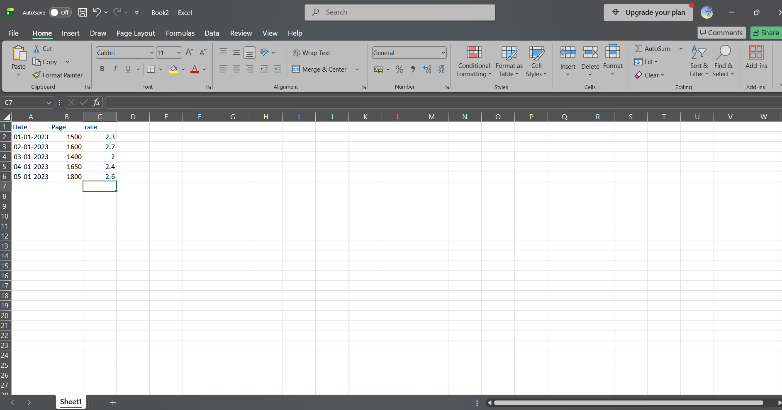
Output 4: Website Traffic Analytics Dashboard
Observation: The dashboard combines daily page views and click-through rate into a single interactive view. It allows users to compare website traffic and engagement across different dates.

Procedure
1. Create the date and page-view vectors in R.
2. Use plot() to create the daily page views line chart.
3. Create the CTR data and select the top three days using sorting.
4. Use barplot() to create the top CTR days bar chart.
5. Create sample likes, shares, and comments data.
6. Use ggplot2 and tidyr to create the stacked area chart.
7. Create an Excel file containing date, page views, and CTR.
8. Connect the Excel file to Tableau.
9. Create the page views line chart and CTR bar chart.
10. Combine both charts into an interactive Tableau dashboard.

Result
The website analytics data was successfully visualized using line, bar, and stacked area charts. An interactive Tableau dashboard was also created to analyze daily page views and click-through rates.

